The university of Azad Jammu and Kashmir ,Muzaffarabad


Student Name: Qurat Ul Ain Fatima
Roll No: 2024-SE-05
Course Title: Database Systems
Course Code: CS-2204
Lab Instructor: Awais Rathore

Lab #12
1. Introduction
In this lab, I worked with aggregate functions in MySQL to summarize and analyze data stored in a relational database. Aggregate functions are used when information from multiple rows needs to be combined into a meaningful summary.
The main aggregate functions covered in this lab were:
- COUNT() – used to count rows or values.
- SUM() – used to calculate the total of numeric values.
- AVG() – used to calculate the average.
- MIN() – used to find the smallest value.
- MAX() – used to find the largest value.
I also practiced using GROUP BY to generate summaries for different categories and HAVING to filter groups after aggregation. In addition, I used aggregate functions together with joins to produce useful reports from multiple related tables.

2. Objectives
The objectives of this lab were:
- To understand the concept of aggregate functions.
- To use COUNT, SUM, AVG, MIN, and MAX.
- To understand the difference between COUNT(*) and COUNT(column).
- To understand how NULL values are handled by aggregate functions.
- To use COUNT(DISTINCT) for counting unique values.
- To use GROUP BY for category-wise calculations.
- To understand and apply the Golden Rule of GROUP BY.
- To use HAVING for filtering groups.
- To understand the difference between WHERE and HAVING.
- To combine aggregate functions with joins.
- To calculate customer spending, product quantities, and category revenue.
- To practice aggregate queries on a RetailStore database.

Database Used
For this lab, I used a database named agg_lab. The database contains three related tables:

- Customer
- Product
- OrderItem
The tables are connected using primary keys and foreign keys. The OrderItem table stores information about products purchased by customers.
5. Database and Data Setup
First, I created the required database and tables in MySQL. After creating the tables, I inserted the provided customer, product, and order data.
The database was intentionally designed with some NULL and missing values. For example, one customer has no recorded city, while another customer has no orders. These values are useful for demonstrating NULL handling and LEFT JOIN operations.

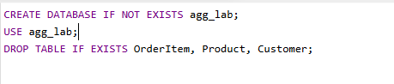
2. Create Customer Table
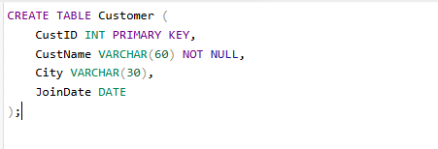
Insert Customer Data
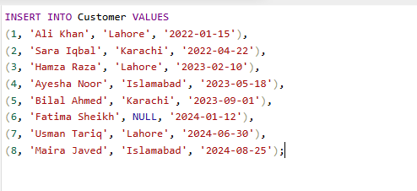
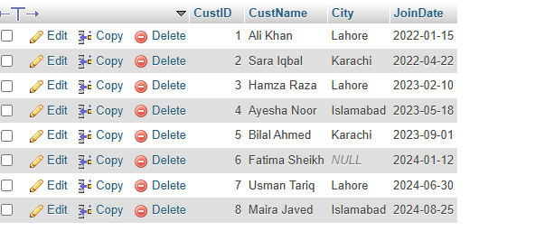

3. Create Product Table
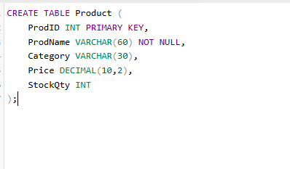
Insert data
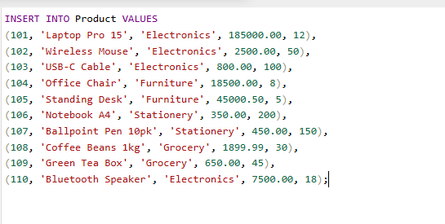
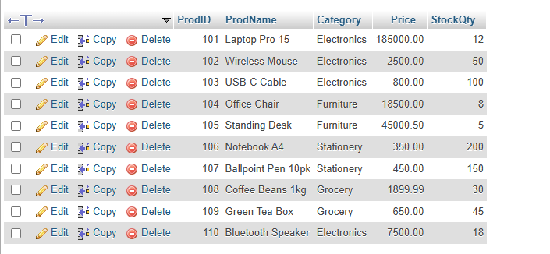

4. Create OrderItem Table

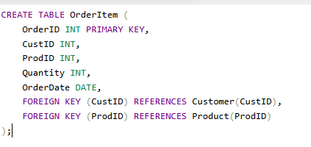
Insert data
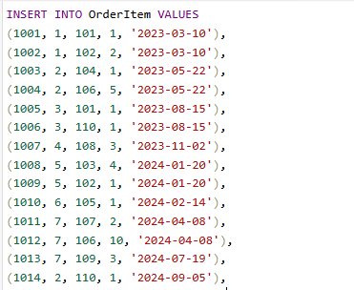
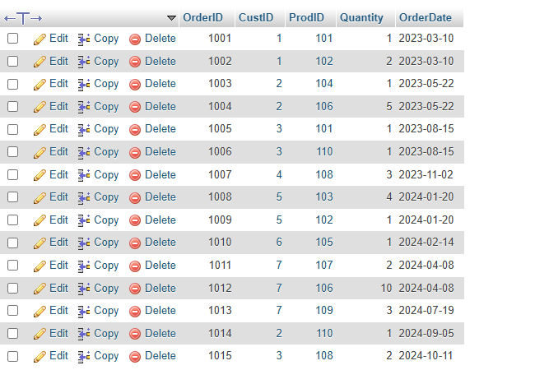
6. Understanding Aggregate Functions
Aggregate functions operate on a collection of rows and return a summarized value.
This is different from scalar functions. A scalar function works with one row and normally produces one value for that row, whereas an aggregate function works with multiple rows and produces a summary.
For example, an average price can be calculated for all products using an aggregate function.
The five main aggregate functions used in this lab were:
COUNT()
Counts rows or non-NULL values depending on how it is used.
SUM()
Calculates the total of numeric values.
AVG()
Calculates the arithmetic average of numeric values.
MIN()
Returns the smallest value.
MAX()
Returns the largest value.

Handling NULL Values
During the lab, I also observed how aggregate functions handle NULL values.
COUNT(*) counts all rows, including rows containing NULL values.
COUNT(column) counts only the rows where that particular column contains a non-NULL value.
Similarly, SUM() and AVG() ignore NULL values.
COUNT(DISTINCT column) counts only distinct non-NULL values.
This difference is important when working with incomplete database records.
Whole-Table Aggregates & COUNT Variations
A1 — Counting Records
I calculated the total number of:
- Customers
- Products
- Orders
This helped me understand how COUNT() can be used to determine the number of records in different tables.
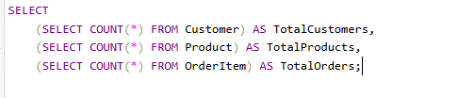

A2 — Minimum and Maximum Price
I found the cheapest and most expensive products using minimum and maximum values.
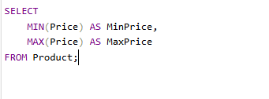
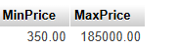

A3 — Average Product Price
I calculated the average price of all products and rounded the result to two decimal places.
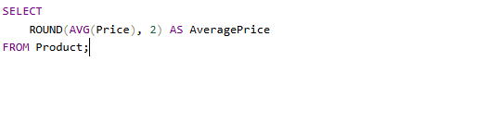

A4 — Total Stock
I calculated the total stock quantity available across all products.
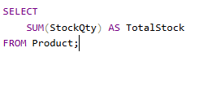


A5 — Distinct Customer Cities
I calculated the number of different cities represented in the Customer table while ignoring NULL values.
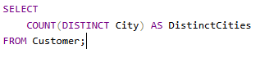

A6 — Distinct Product Categories
I calculated the number of unique product categories in the Product table.
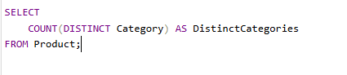
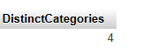
A7 — Customers With and Without City
I calculated how many customers had a recorded city and how many customers did not have a recorded city.
This task demonstrated the difference between counting all records and counting only non-NULL values.
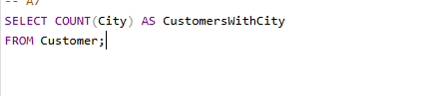
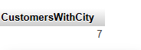
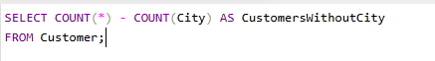
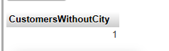

A8 — Earliest and Latest Order
I identified the earliest and latest order dates available in the OrderItem table.
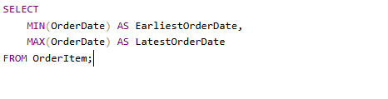
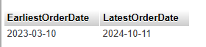
A9 — Total Revenue
I calculated the total revenue generated from all orders. The revenue for each order item was determined from the quantity purchased and the corresponding product price.
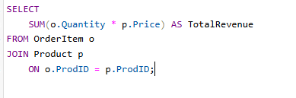
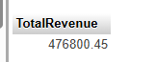

A10 — Average Quantity
I calculated the average quantity recorded for the orders and rounded the result to two decimal places.

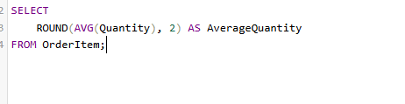


Part B — GROUP BY, HAVING and JOINs
B1. Number of customers in each city
I grouped customers according to their city and calculated the number of customers in each city.
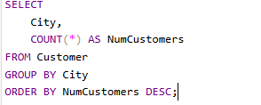
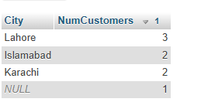

B2. Number of products in each category
I grouped products according to category and calculated the number of products in each category.

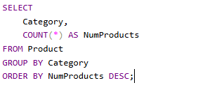
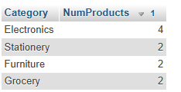
B3. Average, minimum and maximum price for each category
For every product category, I calculated:
- Average price
- Minimum price
- Maximum price

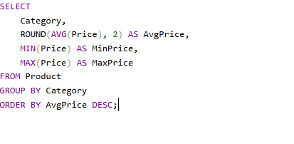
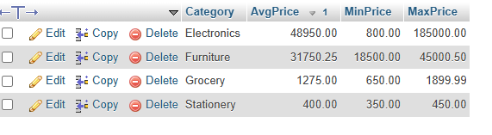
B4. Total stock quantity per category
I calculated the total stock quantity available in each product category.
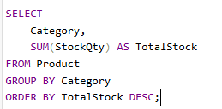
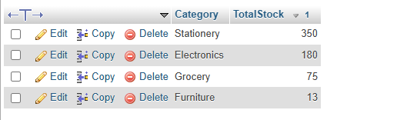

B5. Number of orders in each year
I grouped orders according to the year of the order date and calculated the number of orders for each year.
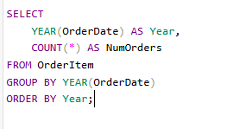
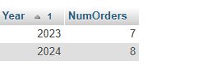
B6. Number of orders in each month of 2024
I calculated the number of orders placed during each month of 2024.
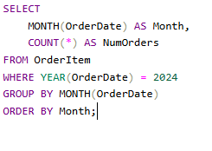
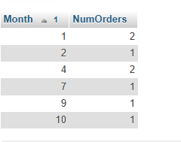

B7. Categories with average price greater than 5,000
I identified product categories whose average product price was greater than 5,000.
This task demonstrated the use of GROUP BY together with HAVING.

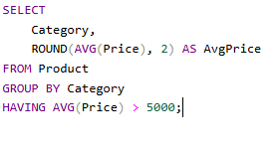
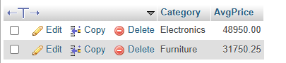

B8. Cities with more than 1 customer
I found cities having more than one customer while excluding customers whose city value was NULL.
This task demonstrated the combined use of WHERE, GROUP BY, and HAVING.

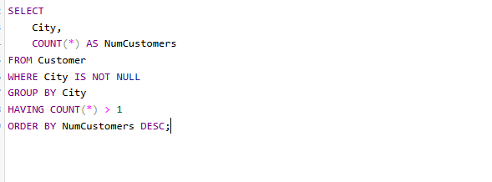
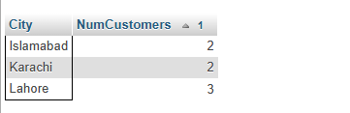

B9. Number of orders for each customer
I calculated the number of orders placed by each customer.
A LEFT JOIN was used so that customers with zero orders were also included in the result.
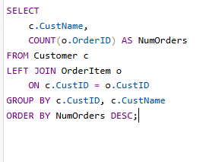
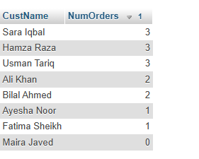
B10. Total quantity sold for each product
I calculated the total quantity sold for every product.
Products that had never been sold were also included in the result with a total quantity of zero.
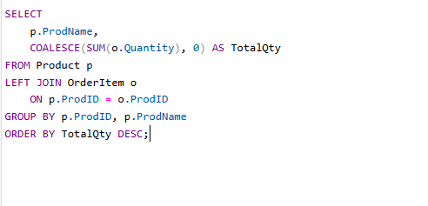
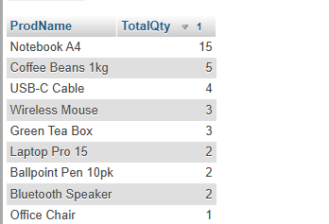

B11. Total revenue per product category
I calculated the total revenue generated by each product category.
This required joining the OrderItem and Product tables and then grouping the results by category.

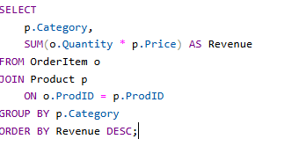
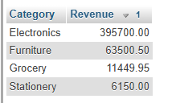

B12. Total spend for each customer
I calculated the total amount spent by each customer.
Customers without any orders were also included using a LEFT JOIN

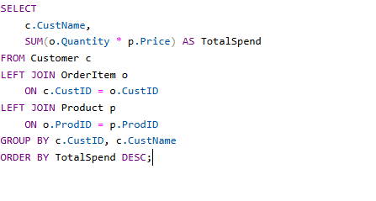
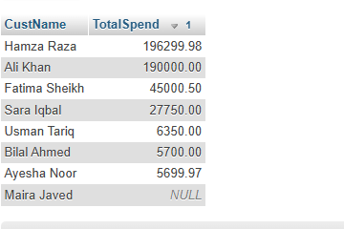
B13. Customers whose total spending exceeds 50,000
I identified customers whose total spending was greater than 50,000.
This task demonstrated the use of HAVING with an aggregate calculation.

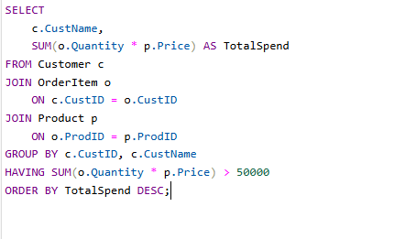
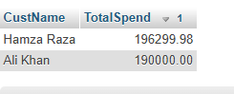

B14. Customer count and revenue for each city
For each city, I calculated:
- Number of customers
- Total revenue generated
Only cities having more than one customer were included.

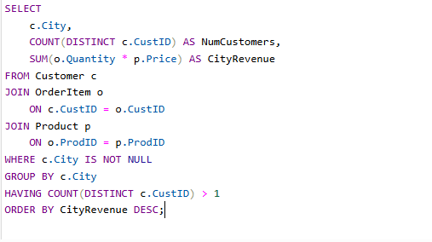
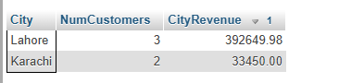

B15. Top 3 best-selling products

I identified the three products with the highest total quantity sold.
This task used grouping, sorting, and limiting the number of returned records.

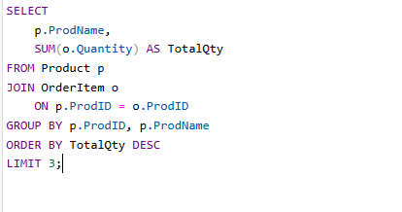
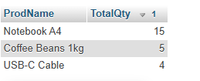

B16. Total revenue for each year
I calculated the total revenue generated in each year and arranged the results according to year.

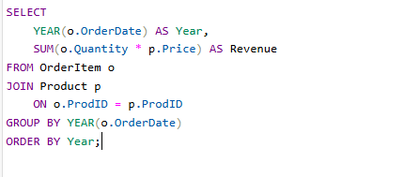
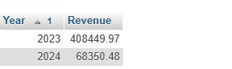

B17. Average order value
For this task, I first determined the total value of each individual order. After that, I calculated the average of those order values.
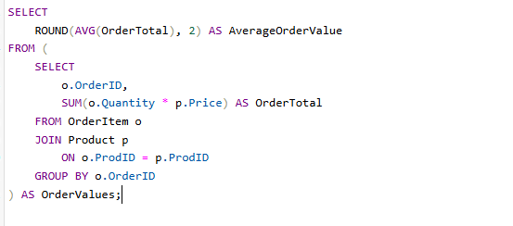


Use of JOIN with Aggregate Functions
One important part of this lab was combining joins with aggregate functions.
The Customer, Product, and OrderItem tables contain related information. By joining these tables, I was able to calculate useful information such as:
- Total spending by customer
- Total revenue by category
- Quantity sold for each product
- Revenue generated by each city
A LEFT JOIN was particularly important when I needed to include customers or products that did not have matching order records.

Logical Order of Query Execution
During the lab, I also learned the logical order in which MySQL processes a query:
- FROM / JOIN
- WHERE
- GROUP BY
- HAVING
- SELECT
- ORDER BY
- LIMIT
Understanding this order helps explain why WHERE is used for row-level conditions while HAVING is used for group-level aggregate conditions.
Important Observations
During this lab, I observed the following:
- Aggregate functions summarize multiple rows into meaningful results.
- COUNT(*) and COUNT(column) can produce different results when NULL values exist.
- COUNT(DISTINCT column) is useful for finding unique values.
- GROUP BY allows aggregate calculations to be performed separately for different groups.
- HAVING is used when the filtering condition depends on an aggregate.
- WHERE filters records before grouping.
- LEFT JOIN allows records with no matching rows to remain in the result.
- Aggregate functions can be combined with joins to produce practical business reports.
- ORDER BY can be used to arrange aggregate results.
- LIMIT can be used to retrieve only a specified number of results.
Common Errors Avoided
While performing the lab, I kept the following points in mind:
- I did not use aggregate functions directly inside WHERE.
- I used HAVING when filtering based on aggregate values.
- I made sure that non-aggregated columns in grouped queries were included in GROUP BY.
- I used COUNT(column) carefully when NULL values were present.
- I used COUNT(DISTINCT column) when I needed unique values.
- I used LEFT JOIN when records with zero activity needed to be included.
- I checked the join conditions to avoid incorrect or duplicated aggregate results.

Results
- After completing the lab, I successfully performed aggregate calculations on the RetailStore database. I used COUNT, SUM, AVG, MIN, and MAX to summarize data and used GROUP BY to generate category-wise and customer-wise reports.
- I also successfully applied HAVING to filter aggregated groups and used joins with aggregate functions to calculate revenue, customer spending, product sales, and other useful summaries.
- The screenshots included in this lab manual show the queries and their corresponding results.

Conclusion
- In this lab, I learned how aggregate functions can be used to summarize large amounts of database information. I practiced COUNT, SUM, AVG, MIN, and MAX, along with GROUP BY and HAVING.
- I also learned the importance of handling NULL values correctly and using LEFT JOIN when records with no related activity need to be included.
- Overall, this lab helped me understand how aggregate functions and grouping can be used to convert raw database records into useful and meaningful information.

